**Het instaleren van de nodemcu esp8266 met de vs1053**

Om de node(muziek box) werkend te krijgen hebben we 3 onderdelen nodig, de vs1053(mp3 decoder), nodemcu eps8266 en een geluidsbox of oordopjes.   
Hieronder een schema om de I/O pins aan elkaar te koppelen.

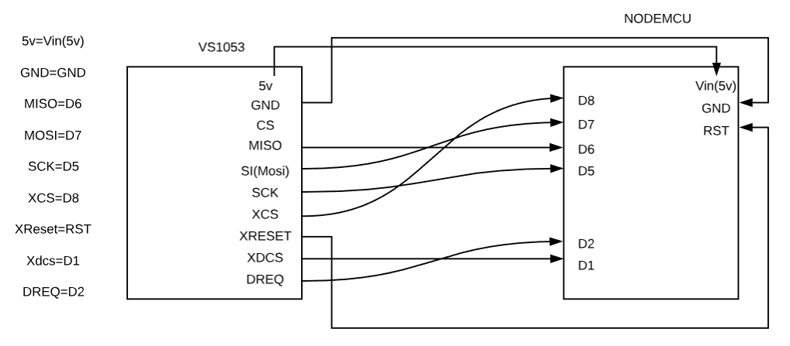

**Benodigdheden voor de software**

-Arduino IDE  
-library’s (  
esp8266.Wifi  
1. file>preference>additional boards manager URLs:http://arduino.esp8266.com/stable/package_esp8266com_index.json>save  
2. sketch>include library>manage library>esp8266  
)

- #include <SPI.h>  
-#include <Adafruit_VS1053.h>  
-#include <ESP8266WiFi.h>  
-#include <ESP8266WebServer.h>

-setup your wifi account(ssid and password)

**Node httpRequests**

start the music  
 type= get

path= ipadress+”/start”

parameter= null

return= String and response code

stop the music  
 type= get

path= ipadress+”/stop”  
 parameter= null

return= String and response code

change the volume  
 type= get

path= ipadress+”/changevolume?vol={int volume}  
 parameter= int volume

return= String and response code

change the station

type= get

path= ipadress+”/changepath?hots={host url}&path={path url}

parameter= string host, string path

return= String and response code

**Server communication**

**NODEINFO:**

get all the nodes:

type= get

path="nodeinfo/getnodes"

parameter= null

return= List<node>={"name":"room","ip":"http://172.20.10.55"}

Add new node:

type=post

path="nodeinfo/addnode"

parameter= Node node =

{

"name":"room",

"ip":"http://172.20.10.55"

}

return=bool

rename node:

type=post

path="nodeinfo/renamenode/{oldname}/{newname}"

parameter=string oldname, string newname

return=String name

remove node:

type=delete

path="nodeinfo/deletenode/{nodename}"

parameter=string nodename

return=bool

**NODEMUSICOPERATIONS**

start music:

type=post

path="node/start"

parameter=List<string> nodeIps "http://192.168.0.4"

return=String

stop music:

type=post

path="node/stop"

parameter=List<string> nodeIps [{"http://192.168.0.4"}]

return=string

Change volume:

type=post

path="node/changevolume/{volume}

parameter=List<string>[{"http://192.168.0.4"}], nodeIps,int volume

return=String

change radio station:

type=post

path="node/changeradiostation/{stationname}"

parameter=List<string> nodeIps [{"http://192.168.0.4"}],string stationname

return=String

**RADIOSTATION**

get radio station names:

type=get

path="stationnames”

parameter=null

return=List<string> stationNames

get radio station by name

type=get

path="stationbyname/{name}"

parameter=string name

return= RadioStationModel radiostation=

{

"name": "radio 1",

"host": "icecast.omroep.nl",

"path": "radio1-bb-aac",

"country": "holland"

}

**USER**

authenticate user login:

type=post

path="user/login"

parameter=UserModel user=

{

"name":"admin",

"password":"admin"

}

return=bool